# Sustainable Smart City Assistant Project: Agile Report

## 📆 Sprint Duration

• Sprint Duration: 2 Days Each

• Sprint Timeline: 20 June 2025 to 28 June 2025

## 🗓 Product Backlog & Sprint Schedule

|  |  |  |  |  |  |
| --- | --- | --- | --- | --- | --- |
| **Sprint** | **Functional Requirement (Epic)** | **User Story Number** | **User Story / Task** | **Story Points** | **Priority** |
| **Sprint-1** | Recycle Management | USN-1 | As a user, I can enter a recyclable item and receive advice on how to dispose or reuse it properly | 3 | High |
| **Sprint-1** | Recycle Management | USN-2 | As a user, I can get eco-tips for my neighborhood based on my pin code | 2 | Medium |
| **Sprint-2** | Image Generation | USN-4 | As a user, I can input a text prompt to generate a sustainable city image using an AI model | 3 | High |
| **Sprint-2** | Image Generation | USN-5 | As a user, I can download and share the generated image | 2 | Medium |
| **Sprint-3** | Problem & Solution (RAG) | USN-6 | As a user, I can enter a sustainability issue and get AI-generated solutions with relevant documents | 4 | High |
| **Sprint-3** | Problem & Solution (RAG) | USN-7 | As a user, I can get real-time summaries of city issues and resolutions | 2 | Medium |
| **Sprint-4** | City Comparison & Health Dashboard | USN-8 | As a user, I can compare two cities based on air quality, traffic, and waste data | 4 | High |
| **Sprint-4** | City Comparison & Health Dashboard | USN-9 | As a user, I can access a real-time city health dashboard visualized with charts | 3 | High |

## 📊 Sprint Tracker

|  |  |  |  |  |  |  |
| --- | --- | --- | --- | --- | --- | --- |
| **Sprint** | **Total Story Points** | **Duration** | **Sprint Start Date** | **Sprint End Date** | **Story Points Completed** | **Sprint Release Date** |
| **Sprint-1** | 8 | 2 Days | 20 June 2025 | 21 June 2025 | 8 | 21 June 2025 |
| **Sprint-2** | 5 | 2 Days | 22 June 2025 | 23 June 2025 | 5 | 23 June  2025 |
| **Sprint-3** | 6 | 2 Days | 24 June 2025 | 25 June 2025 | 6 | 25 June  2025 |
| **Sprint-4** | 7 | 2 Days | 26 June 2025 | 27 June 2025 | 7 | 27 June  2025 |

## 📈 Velocity

• Sprint Duration: 2 Days Each

• Sprint-1 Velocity: 4 Story Points per Day

## 📉 Sprint-1 Burndown Chart

Ideal Burndown vs Actual Burndown (2-Day Sprint):

|  |  |  |
| --- | --- | --- |
| **Day** | **Ideal Story Points Remaining** | **Actual Story Points Remaining** |
| 1 | 8 | 8 |
| 2 | 0 | 0 |

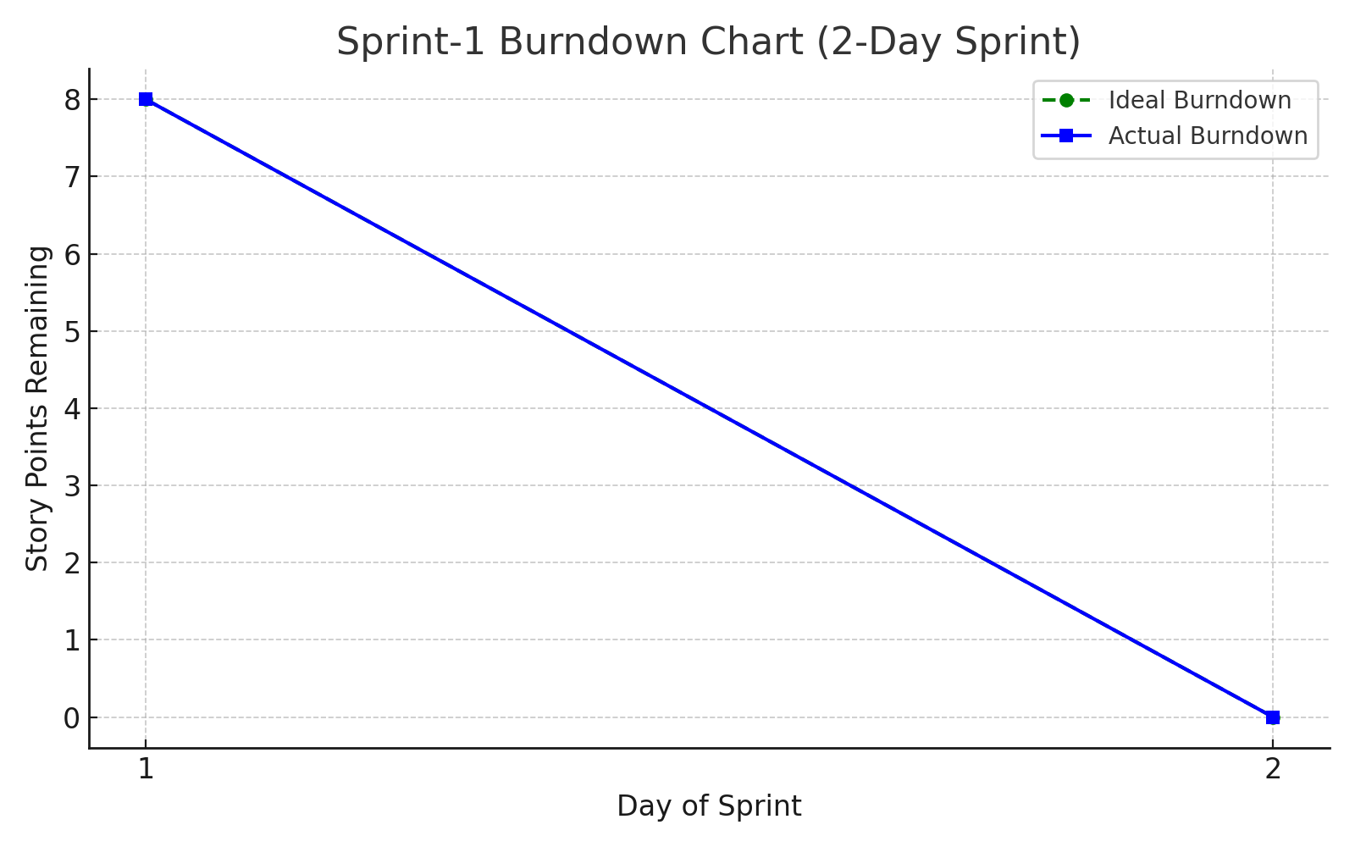

## 🚀 Summary

• The team successfully completed all planned tasks for Sprint-1 within 2 days.  
• Future sprints are scheduled every 2 days, ending by 28 June 2025.  
• All five modules of the assistant will be completed across 4 sprints.